A Guide to the Deactivation of Shock Therapies of Implantable Cardiac Defibrillators (ICDs) in Greater Manchester
(incorporating British Heart Rhythm Society guidelines)



December 2025

Section | Contents | Page
1 | Introduction | 3
2 | Discontinuation of ICD Shock Therapies Towards The End of Life: A Practical Guide (British Heart Rhythm Society, 2024) | 5
Appendix 1 | Magnet application to disable tachycardia therapies in Implantable Cardioverter Defibrillators (ICDs) | 15
Appendix 2 | Contact details for Greater Manchester and Eastern Cheshire hospital sites | 16
Appendix 3 | GMEC template for the emergency use of a magnet for patient with ICD who is imminently dying | 18
Appendix 4 | GMEC template for requesting the reprogramming of an implantable cardioverter defibrillator (ICD) to turn tachycardia therapies off | 20

Introduction
  - This document has been developed by the Greater Manchester and Eastern Cheshire Strategic Clinical Network (GMEC SCN) in conjunction with local clinical staff from both the cardiac and palliative care sectors. It is designed to support local services in the development and/or review of their own policies and procedures for the reprogramming of Implantable Cardiac Defibrillators (ICD) or Cardiac Resynchronisation Therapy Defibrillator (CRT-D) for patients with such devices who have been identified as being at, or nearing, the end of life.

  - The document is substantially based upon the guidance issued by the British Heart Rhythm Society (BHRS) in January 2024, which clearly outlines the roles and responsibilities for staff and teams once the decision to deactivate shock therapies has been taken.

  - This guidance will support primary and secondary care providers to develop their own policies and protocols for reprogramming ICDs to turn tachycardia therapies off, proposing a framework that will help everyone responsible for the care of patients receiving ICD therapy to deliver high quality care.

  - These guiding principles will support the development of local policies to cover deactivation of devices in:
    - Hospitals.
    - Community settings including hospices.
    - Post-mortem deactivation

  - The central tenet of this document is the desirability of advanced discussions around appropriate reprogramming of the ICD to enable the elective withdrawal of tachycardia therapies. All local policies developed in line with these principles must define, encourage and promote this discussion in advance, taking place as early as appropriate in the patient’s management to enable proactive care and in turn avoiding unnecessary distress to patients and their families and carers.

  - Local policies should outline the roles and responsibilities required both organisationally and individually, and ensure that they:
- Have systems in place that clearly document patients with implanted ICD in accordance with SNOMED CT (Systematised Nomenclature of Medicine Clinical Terms (6).
- Outline how centres that provide follow up devices provide a 7-day service. Other centres will need to determine their weekend cover.
- Clearly outline processes to make sure discussion about end-of-life ICD management occur at the patient’s pre-admission appointment, prior to implant.
- Provide clear processes for arrangement of deactivation during the day, and what procedure to use outside of normal working hours.
- Define who is responsible for deactivation. The responsibility should be assigned to a position (e.g. lead cardiac physiologist) rather than a person.
- Clarify that all coronary care units in Greater Manchester should stock a magnet at all times.
- Include contact numbers for relevant teams and departments responsible for deactivation.
- Outline how communication is maintained with primary and community care.
- Provide clarity of role and responsibilities of individual job roles within the Trust MDT.

1.7 Local policies must provide clear guidance for primary care and community colleagues, i.e.:
- Patients identified as having palliative and end of life care needs either by the EARLY identification process in primary care or the Gold Standards Framework (GSF) should prompt discussion about reprogramming tachycardia therapies off in an ICD between the GP or cardiologist, specialist nurse or other health care worker and the patient.
1.8 Local policies must include clear guidance for Advanced Care Planning and shared decision making:
- Advance care planning including DNACPR and treatment escalation planning should be discussed with the patient at the earliest opportunity.
- Should be offered for all patients.
- Localities should consider the anticipatory care planning guidance including DNACPR to support local documentation such as ReSPECT, Advance Care Plans or DNACPR documentation
1.9 Local policies must provide guidance for postmortem removal. (to include suspected/confirmed COVID-19) i.e.
- Reprogramming shocks off in an ICD and the removal of the ICD must occur after death and prior to cremation.
- Local arrangements need to be put in place to make sure this occurs.
2.0 Local policies should try to use GM agreed templates and letters in as outlined in the appendices:
- For using an emergency magnet use for patient with an ICD who is imminently dying (Appendix 3)
- For requesting the reprogramming of an ICD to turn tachycardia therapies off (Appendix 4)
- Standard referral letters /feedback



DISCONTINUATION OF ICD SHOCK THERAPIES TOWARDS THE END OF LIFE: A PRACTICAL GUIDE

January 2024

Background

Implantable Cardioverter Defibrillators (ICDs) are used for patients who have had either a sudden previous cardiac arrest or are at high risk of sudden cardiac death from an arrhythmic cause.
An ICD can deliver either rapid burst pacing or a shock with the aim of terminating a ventricular arrhythmia (ventricular tachycardia or ventricular fibrillation) and restore normal cardiac rhythm. Most ICDs also function as a pacemaker to either prevent slow heart rates or as part of cardiac resynchronisation therapy (CRT or biventricular pacing). CRT devices synchronise contraction of the left and right ventricles and thereby reduce symptoms in some people with heart failure. A CRT device may function solely as a pacemaker (CRT-P) or also function as an ICD-these are referred to as CRT-D devices. The pacemaker and ICD functions of each device are programmable independently of each other.
Most ICDs are implanted in the left or right upper pectoral region and leads run through the veins into the heart. A recent development is the use of subcutaneous ICDs (S-ICDs) where the leads run in the anterior chest wall.
These devices have very limited pacing function. The generator is typically found in the left lateral chest wall beneath the axilla.

Due to the increasing indications for ICD implantation, the number of people with ICDs has also increased. People are also living longer with these devices. As a result, an increasing number of patients with an ICD will deteriorate either with worsening cardiac failure, another non-cardiac condition or general frailty and will have a limited prognosis. Therefore, to ensure the person receives high-quality end-of-life care, they should have the opportunity to consider and discuss the option to deactivate the shock function of their ICD.

If the ICD shock therapy is not discontinued, there is an increased risk that as a person reaches the last days of life, the ICD may deliver multiple, painful shocks which are distressing (2). There is also a risk that the device may delay the person’s natural death which the person would not have chosen if they had been given the opportunity to discuss discontinuation.

Ethical and Legal Aspects

If a person with capacity requests withdrawal of treatment, despite being fully informed of the likely consequences, healthcare professionals must comply with that request, even when they consider the request unwise or illogical or when the withdrawal of treatment is contrary to medical advice. Should an individual healthcare professional be unwilling to act where there is a properly established decision to deactivate an ICD, it will be necessary to identify another healthcare professional to carry out discontinuation. Some people may be concerned that ICD discontinuation could be interpreted as a form of assisted dying, and as analogous to voluntary euthanasia or assisted suicide. That is not the case (1).

Who should have discussions regarding ICD shock therapy discontinuation?

Decisions about discontinuation of any device should be shared decisions, with full involvement of the patient themselves and the healthcare team caring for them and must be based on careful assessment of the individual’s circumstances at the time. When people lack capacity, decisions must be made in their best interests, must be made according to the law in that jurisdiction and must involve those with legal power to make decisions on their behalf. This is more straightforward if the family have Power of Attorney. The views of those close to the patient should be considered when making a best-interests decision in such circumstances. If a patient has Learning disabilities, it is important to involve local learning difficulty advisory teams to support decision making.

It may be necessary to involve several members of the healthcare team and to have serial discussions with patients and those close to them before reaching a shared decision with which they are comfortable. The appropriate members of the healthcare team to contribute to this will vary.

Depending on individual circumstances the healthcare professionals who initiate and undertake these discussions or provide support and information to patients and those close to them may include:

- Cardiologists
- Heart failure specialist nurses
- Arrhythmia specialist nurses
- Cardiac physiologists (especially those involved in device management)
- General practitioners
- Non-cardiologist physicians or surgeons
- Palliative care doctors or specialist nurses

What should we explain about ICD shock therapy discontinuation?

Conversations about end of life and device discontinuation can be uncomfortable and challenging for patients and health professionals. There are some common myths regarding ICD shock discontinuation which it is important to address. Some of the important information to share is outlined below.

- Near the end of a person’s life, the ICD may deliver shocks that are painful and distressing and are of no benefit.
- Discontinuation of shock therapy from an ICD is not the same as completing a DNACPR order but one may prompt discussion of the other.
- Discontinuation of shock therapy from an ICD will not cause death. Once an ICD has been deactivated, if a patient has a heart rhythm change that could cause death, the ICD will not deliver treatment.
- Discontinuation of shock therapy of an ICD does not deactivate its pacemaker function.
- Discontinuation of shock therapy from an ICD is painless and does not require surgery. However, it does need to be done face to face.
- Magnet discontinuation of ICD shocks requires a medical grade magnet and is only temporary. A programming device provides reliable discontinuation of shocks.
- If a patient’s clinical condition improves unexpectedly or they change their mind the ICD can be reactivated.
- It is best to think and decide about ICD discontinuation in advance and in the context of more comprehensive advanced care planning rather than in a crisis.

Patients should be offered written information about ICD shock discontinuation e.g., Resuscitation Council UK guidance for discontinuation the shock function of an ICD towards the end of life: A guide for patients and carers (3).
Any discussions and decisions should be clearly documented in the patient clinical record and shared with all members of the healthcare team including the primary care team.

When should ICD shock therapy discontinuation be discussed?
Any discussions regarding ICD discontinuation should be introduced as early as possible and at a time which is appropriate to the individual patient and their family. Ideally these conversations should be part of wider advance care planning rather than in isolation. This will vary but specific situations which may trigger a conversation about possible device discontinuation may include the following. The shared decision making prior to ICD implantation should include discussions around
possible shock therapy discontinuation in the future (an example of a shared decision making aid is available on the BHRS website (4).
  - Prior to implantation, at the time of consultation, as part of the informed consent process
  - When requested by a patient or family member.
  - During assessment for device replacement (elective replacement due to battery depletion or advisory)
  - Multiple shocks being delivered as a result of disease progression
  - A change in clinical status; worsening of condition or new comorbid condition with a poor prognosis (e.g. advanced malignancy, dementia).
  - Frailty. Frailty indices such as the Charlston comorbidity index may be helpful (5).
  - Repeated hospitalizations for heart failure
  - Repeated emergency department visits
  - Refractory symptoms of a cardiac condition despite optimal therapy
  - Deemed ineligible for advanced heart failure therapies (e.g. mechanical circulatory support or transplant)
  - Deteriorating quality of life and functional status
  - The presence of a DNAR order, although the two are separate decisions
  - When referred to hospice or a nursing home facility
  - At a minimum, during annual device clinic visit, or during other device clinic visits

Many patients now receive remote follow up for their ICDs which may reduce face to face contact. These patients should be encouraged to get in touch with the clinical teams if they feel their condition has changed, or if they would like to make some plans for their future care such as de-activating the shock aspect from the defibrillator.
A decision not to attempt resuscitation in the event of a cardiorespiratory arrest (DNAR) should always prompt consideration of ICD shock therapy but it should not be assumed that this will always be appropriate.
It is preferable that any discussions regarding ICD shock therapy discontinuation take place in advance. Unfortunately, these discussions often occur in emergency situations which can cause distress and present practical challenges to facilitate urgent device discontinuation. A proactive approach to identify patients who may be approaching the time for shock discontinuation can reduce stress and distress for the patient, family, and healthcare professionals. All members of the team involved in follow up of these patients should be encouraged to flag any general deterioration in the patient’s health or functional status to the device follow up team. It may be that ICD shock discontinuation is discussed many times before an eventual decision is made.

Generator Replacements
When patients with an ICD are approaching generator replacement due to battery depletion, consideration should be made to whether shock therapy is still appropriate. This is particularly important in an ageing patient population.
Considerations should include whether the patients’ cardiac function has changed, any therapies from the device during its lifetime and the patient’s general health and goals as outlined above. We recommend that all patients should have been reviewed (as a minimum) in the year prior to generator change to ensure that the clinical circumstances have not changed, and the factors outlined above have been reviewed.
If patients have had shock therapies discontinued on their device, their battery may still deplete. The device follow-up team should aim to stop any unnecessary device function to prolong the battery. In patients who have had ICD shock discontinuation, it may be necessary to carry out a generator replacement in patients who have pacing requirements to prevent slow heart rates or to treat their heart failure. In this case, a new ICD generator with immediate shock discontinuation may be an acceptable alternative to implantation of a new lead to allow downgrading of the device to a pacemaker. If patients have no pacing needs, it may be reasonable to allow battery depletion to continue without generator replacement once the ICD shocks are deactivated. The device manufacturers are wary of supporting this approach but anecdotally the incidence of adverse events is felt to be low. If this approach is followed there should be a shared decision-making process including the risks and benefits associated and this should be clearly documented.

Device Management after Death
The mortician/funeral director should be informed of the device status. Typically, devices will need to be removed before any cremation and it is crucial that any ICD therapies are switched off with a programmer prior to this. If a magnet was applied at the time of death it should remain in place until formal device discontinuation can take place in the funeral home/mortuary. If the patient is in a hospital setting at the time of death then they should remain in the hospital mortuary until the device is deactivated. Some regions are unable to attend devices in community funeral parlours and local pathways may need to be followed. The device follow-up centre should be informed of this.

How should we deactivate ICD shocks?
The flow chart summarises the process for discontinuation of ICD shock therapy. Where possible, device discontinuation should occur in a device follow up setting (typically a hospital). This is more likely to be possible if device discontinuation is considered early in patients who are deteriorating.
The team should document shock discontinuation in the patient record. Trust policies vary, this may require a specific form in the patient record completed by the responsible clinician and subsequently signed by the cardiac
physiologist/scientist. Some centres may require the patient to sign the form and others may allow verbal consent to be documented. This may be electronic.
Examples of forms are included in the appendix 1 and outline what should be documented in the patient record in the absence of a specific form.

Planned ICD shock discontinuation
ICD shock therapy discontinuation is a simple and quick procedure carried out through a device programmer by an appropriately trained member of the
team. Programmers are manufacturer specific, therefore the patient’s implantable device manufacturer must be known to allow the appropriate programmer to be used. If management plans change, ICD shocks can be reactivated using a similar procedure. All centres who follow up devices (even if not an ICD centre) should be able to discontinue ICD shocks. We would encourage training as many individuals as possible to be able to perform this. This may include junior physiologists/echocardiographers/arrhythmia nurses and cardiologists. Appendix 2 includes some simple guidance for ICD discontinuation in the different manufacturers including screenshots which may be useful to support the process.
If the patient cannot attend the clinic, then the local cardiac physiology team should arrange a domiciliary or community site device discontinuation. It is essential to adhere to the centre’s local lone worker policy to ensure personal safety and well-being of staff, as well as providing a clear protocol in situations where healthcare professionals are working in isolation or in unfamiliar environments.
This can be challenging to deliver in a timely manner, particularly out of usual office hours. This will require support and usually the presence of the community team at the time of device discontinuation. Cardiac device services may have collaborative regional agreements to support delivery of community services across their areas. Once the decision to discontinue shock therapy is made the responsible clinical team should contact the patient’s usual follow up service as soon as possible so appropriate arrangements can be made to attend to the discontinuation in the most appropriate location.
A list of email and phone contacts within the region should be available in local policy documents in addition to any specific paper or electronic referral pathway information. Appropriate forms should be completed (as outlined in roles and responsibilities) section and device discontinuation communicated to the wider healthcare team.

Emergency ICD shock discontinuation
If there is a delay in facilitating ICD shock discontinuation with a programmer, application of a clinical magnet (typically ring/donut) will allow temporary discontinuation of ICD therapies. It will not affect pacing function. Magnets are typically available in hospital cardiology departments, cardiac wards and emergency departments. They may also be available from the ambulance service or local hospice services. If struggling out of hours, the local acute cardiology unit should be able to advise. This should only be a temporary measure as magnet application may be unreliable and uncomfortable. The following steps should be taken when a magnet is used.
- Ask the patient to feel and point to where the ICD is located (if possible), if not then look for the scar usually located to the left below the clavicle. Alternative placement could be on the right or down under the Left arm around the 6th rib.
- Feel for the ICD which will be a solid lump under the skin
- Place the magnet over the lump – you may hear a quiet alarm/vibration as the magnet disables therapies.
- Secure the magnet in place with micropore/transpore, as pictured below to ensure the magnet does not move.

Magnets temporarily stop the ICD delivering shock therapies but only whilst in position over the ICD and normal function is restored as soon as it is removed. Some manufacturers’ devices will reactivate ICD therapies after 8 hours of magnet application. If a patient is known to have a Biotronik ICD (or the manufacturer is unknown), the magnet should be removed and reapplied every 7 hours.
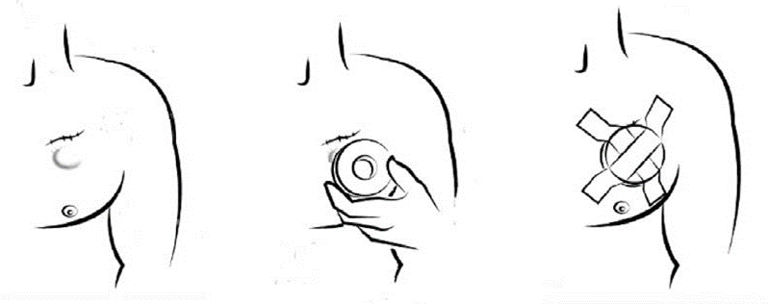

Manufacturer Specific Magnet Application Guidance
Different manufacturers have specific guidance regarding precise magnet positioning. In real world practice, positioning the magnet directly over the device has usually been found to be effective. If it is possible to ascertain the patients’ device manufacturer, then the advice outlined in Appendix 1 should be followed regarding specific magnet positioning. Patients should have a device ID card which will state the manufacturer, they may have a home monitor and can share the name on the unit. It may be possible to access this information from the patient’s usual device fu service or the electronic patient records available. Some manufacturers’ devices will beep or vibrate on magnet application but others do not.

Roles and Responsibilities

Responsibilities of Staff working in Primary Care, Acute Hospital Services or Palliative Care once decision is made to deactivate ICD shock therapy.
  - Informing the patient and their carers of the options and the advantages/disadvantages for turning the tachycardia therapies off as part of a shared decision-making process.
  - Contacting the patient’s usual follow up centre at their earliest convenience, to ask for support with equipment, local contacts or actual reprogramming of ICD shock therapies.
Completing appropriate documentation for the patient record to document the decision making process including specific consent/discontinuation request form if required.
  - If the patient is not currently under the active care of specialist services, it is the responsibility of the patient’s GP/community team to alert such services.

Responsibilities of Cardiac Device Follow Up Service
All centres who offer device follow up (even if this is not for ICDs) should have appropriate training and infrastructure to allow them to respond to needs for device discontinuation in patients in their hospital sites or local community.
- It is the duty of local cardiac physiology staff who deactivate the ICD to document the details in patient’s notes and to communicate the same to the patient’s usual follow up centre with a copy to their GP.
- Completing appropriate documentation for the patient record process including specific consent/discontinuation request form if required.
- The GP and other relevant health professionals should be directly informed and/or sent a copy of the completed ICD therapies discontinuation form.
- Ensure any patient alerts/alarms are deactivated alongside ICD shock therapy discontinuation to prevent any unnecessary patient distress.
- The usual follow up centres should, on being informed of discontinuation/reactivation of a patient's device, amend the devices database and patient file.
- Where necessary, it is essential that the individual discontinuation of shock therapy of any device adheres to the lone worker policy relevant to their employer, providing contact details during any community visits and adheres to any work- related vehicle use policy. Immediate plans should be made to transfer or safely store programming equipment.
- Typically, when community discontinuation is arranged a member of the community healthcare team should be present with the patient when the secondary care cardiac physiologist attends to deactivate the device.

Training requirements of staff groups programming ICDs
- For individuals responsible for the deactivation of ICD therapy it may be beneficial to attend training or education sessions in communicating difficult conversations.
- This may address the needs of individuals discussing the implication of ICD deactivation with patients, carers and relatives. The intention of education sessions should ensure staff groups acquire the necessary skills, knowledge, and confidence required to perform effectively and safely in their particular work environment.
- Whilst there is currently no identified single qualification or course designed specifically for the communication of ICD deactivation, local centres may wish to develop tailored training that addresses the unique requirements and needs of the cardiac physiologist.
- Alternatively there may be local communication courses available.

Flow chart for ICD shock therapy discontinuation
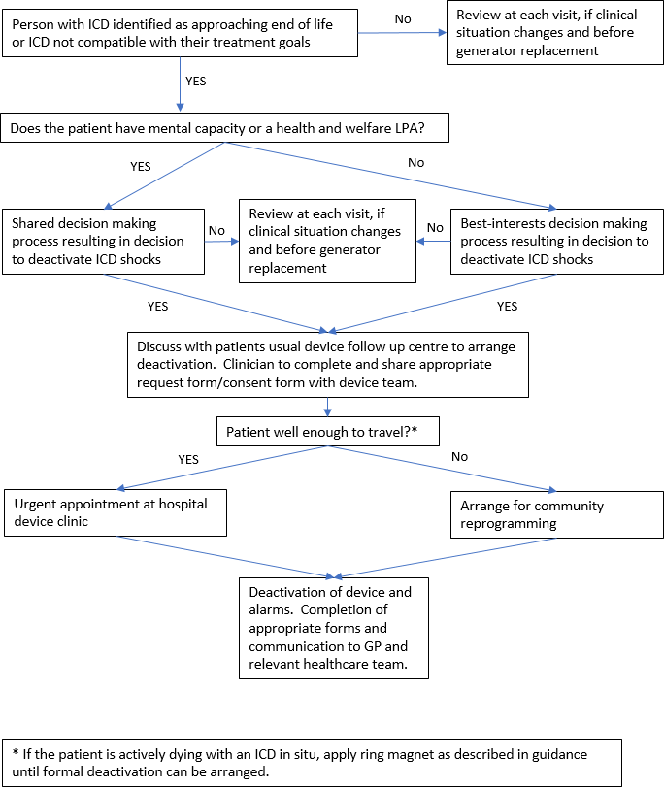

Acknowledgements: Endorsed by the BHRS council with acknowledgement to Dr Honey Thomas, Dr Paul Foley, Heather Herbert, Amy Dutton and Prof Miriam Johnson

References
- CIEDs discontinuation.pdf (resus.org.uk)
- https://www.google.com/url?q=https://www.telegraph.co.uk/news/health/8928 798/ICDs-Imagine-a-horse-kicking-you-in-the-chest-from-the- inside.html&sa=D&source=docs&ust=1699969380241456&usg=AOvVaw36- WCX0ABbAzwy4zAijfj7
- CIEDs leaflet_patients.pdf (resus.org.uk)
- ICD Infographic FINAL March 2018 UK (bhrs.com)
- https://pubmed.ncbi.nlm.nih.gov/31355952/
- SNOMED CT https://www.england.nhs.uk/digitaltechnology/digital-primary-care/snomed-ct/#:~:text=Systematized%20Nomenclature%20of%20Medicine%20Clinical,of%20the%20electronic%20care%20record.

Appendix 1: Magnet Application to disable tachycardia therapies in Implantable Cardioverter Defibrillators (ICDs)
For Medtronic, Sorin and Boston Scientific ICDs (inc. S-ICD model 1010) = companies recommend direct placement of a magnet over the device. Audible tones should be heard for Medtronic and Boston Scientific devices.

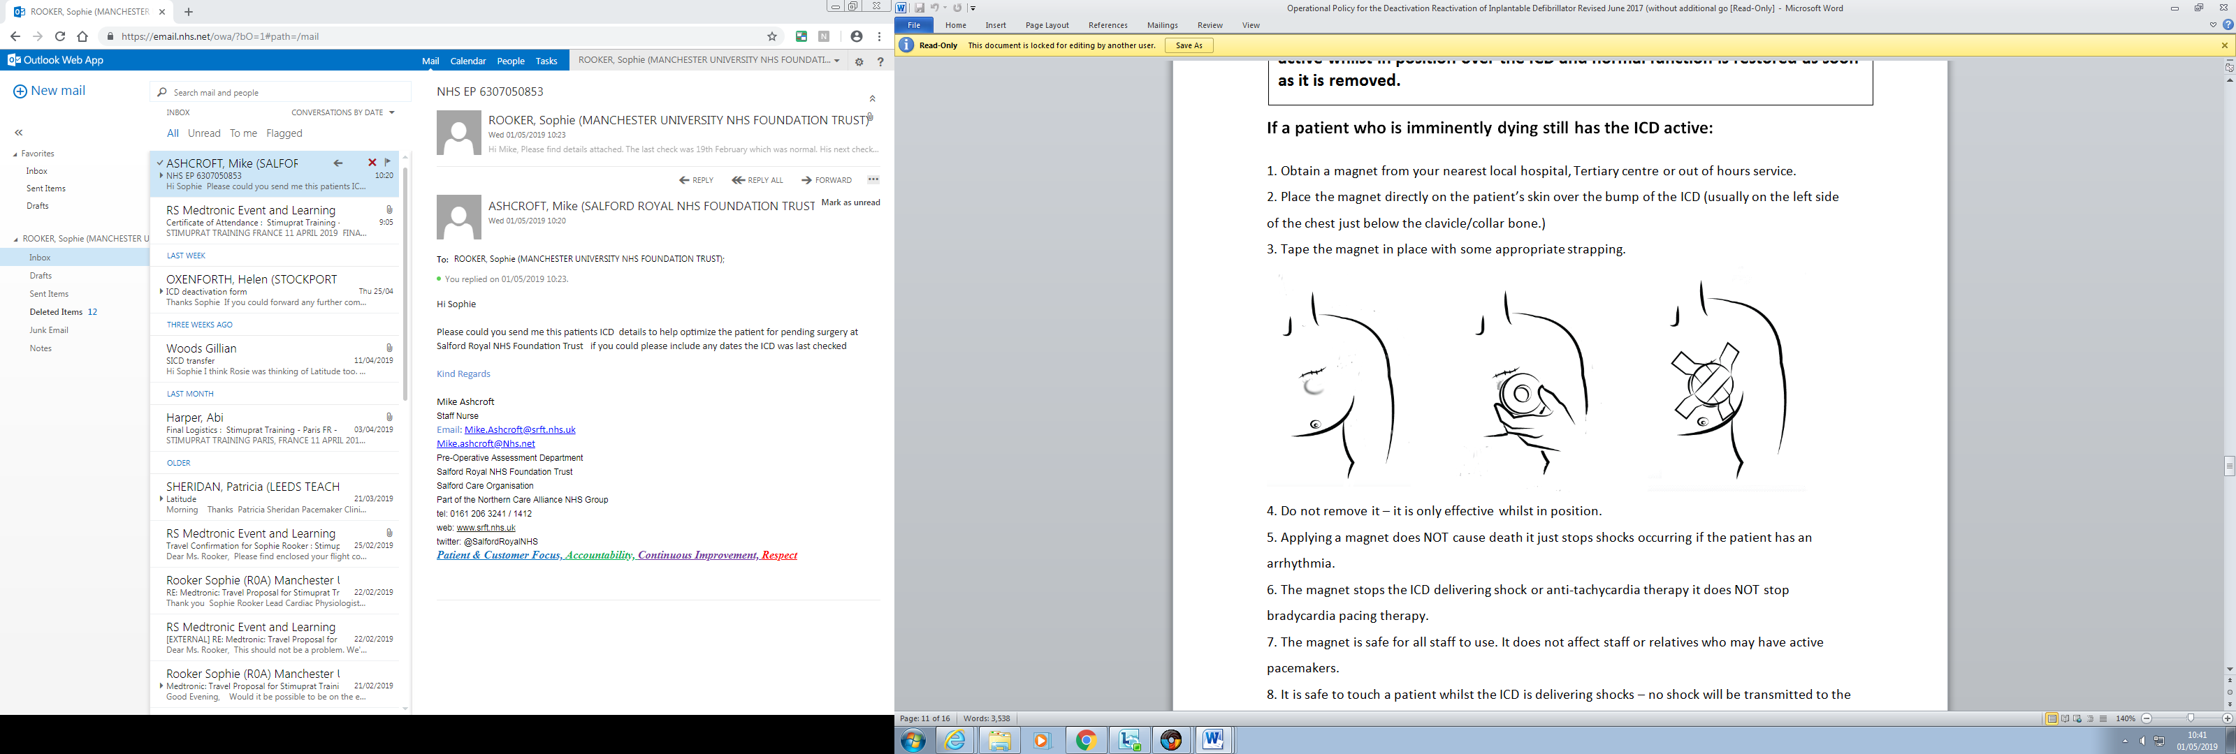
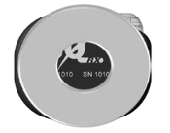
For Boston Scientific Subcutaneous ICDs model A209 Emblem, the company recommend half of the magnet over either edge ↓

For St Jude Medical/Abbott the magnet should be positioned off-center â

Note: Boston Scientific ICDs - If audible tones heard then contact the implanting - magnet application mode may have been switched off, previous MRI scans can disable the beeper tone or the ICD may be from another manufacturer.

S-ICD model 1010

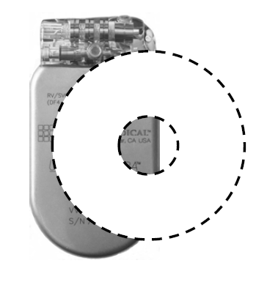
For Biotronik ICDs the magnet should be offset slightly â

Note: Biotronik ICDs - if magnet requires application for >8hrs – remove magnet for a few seconds every 7 hrs and re-apply magnet to keep tachy therapy disabled OR program tachy therapy OFF using a Biotronik programmer.

The patient’s device manufacturer should be on their ICD Identification Card. Otherwise contact the coronary care unit/on call registrar of the patient’s follow up centre in order to obtain this information. Information will likely be on their Electronic Patient Record (EPR) or Cardex/Dendrite (device database).

Appendix 2 – GMEC Hospital Contact Details
Hospital Name | Contact 9-5 | Contact Outside 9-5
Wythenshawe Hospital | Physiologists  0161 291 4615  ICD Nurse Specialists 0161 291 5076 | On call registrar  0161 998 7070  CCU 0161 291 6077
Manchester Heart Centre (MRI) | Physiologists  0161 7017535  Fax: 01612767957  ICD Nurse Specialists 0161 276 4657. | CCU  0161 276 4200  On call registrar  0161 2761234 Bleep 4004
Royal Bolton Hospital | Physiologists  01204 390 166 | On call Cardiologist  01204 390 390 (main hospital)
Royal Oldham Hospital | Physiologists  0161 627 8512 | No out of hours service or contact
Fairfield General Hospital | Physiologists  0161 627 8512  ICD Nurse Specialist  0161 778 8587  Cath Lab Manager  0161 788 2378 | No out of hours service or contact
North Manchester General Hospital | Physiologists  0161 720 2197 | No out of hours service or contact
Salford Royal  Hospital | Physiologists  0161 206 4748/4726 | Heart Care Unit 0161 206 5005/5006
Tameside General Hospital | Physiologists  0161 331 1667 | No out of hours service or contact
Royal Albert Edward Infirmary | Physiologists  01942 822 455/6 | No out of hours service or contact
Trafford General Hospital | Physiologists  0161 701 7535 | No out of hours service or contact
Leighton Hospital | Physiologists  01270 612188 | No out of hours service or contact
Macclesfield General Hospital | Physiologists  01625 661135 | No out of hours service or contact
Stepping Hill Hospital | Physiologists  0161 419 5674/5077 | No out of hours service or contact

APPENDIX 3:

TEMPLATE FOR THE EMERGENCY USE OF A MAGNET FOR PATIENT WITH ICD WHO IS IMMINENTLY DYING

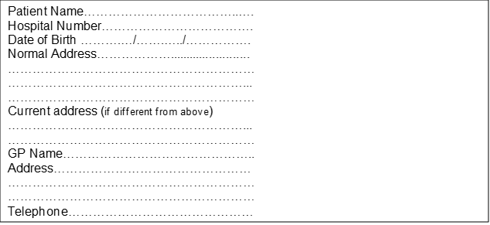
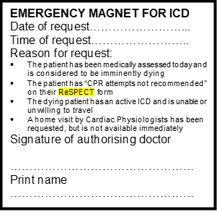

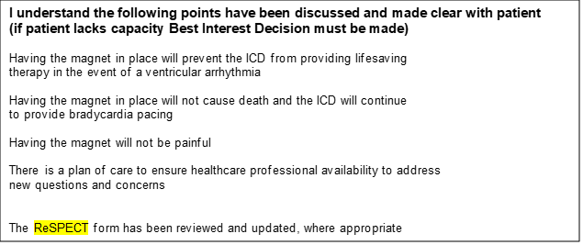

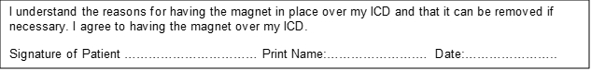

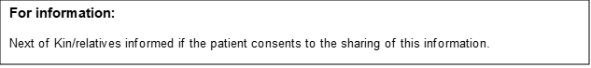
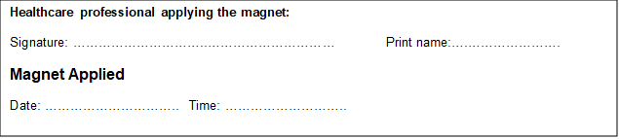

APPENDIX 4:
TEMPLATE FOR REQUESTING THE REPROGRAMMING OF AN IMPLANTABLE CARDIOVERTER DEFIBRILLATOR (ICD) TO TURN TACHYCARDIA THERAPIES OFF

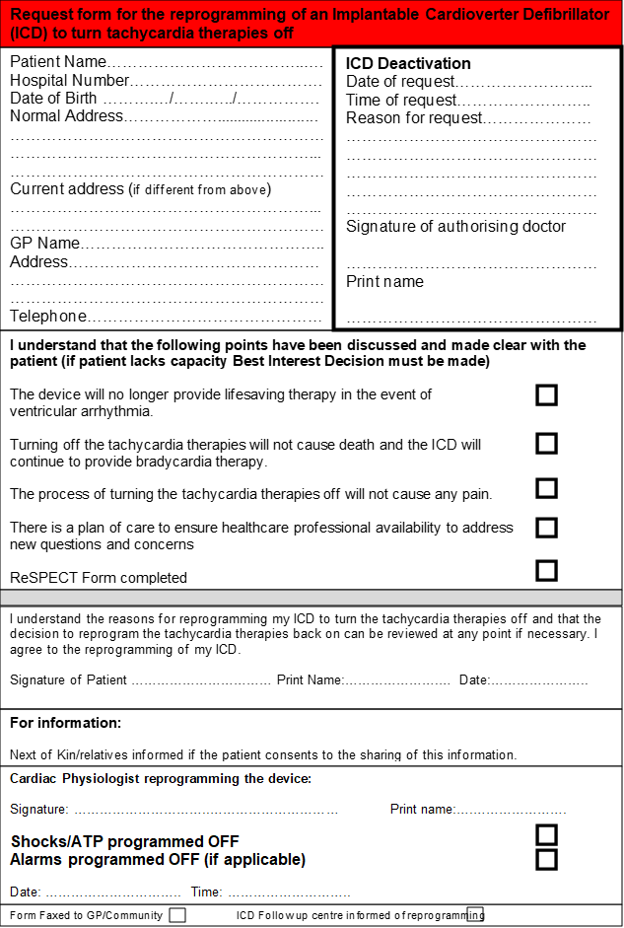

In England, the term ‘end of life care’ refers to the last year of life. (NHS England)

